# WEB DEVELOPMENT

# Project: PG Life Website

Bachelor of Technology

*in*

Computer Science & Engineering

## *Submitted by*

Kanhaiya Mittal 2200521520026

Piyush Agrawal 2200520100046

Under the guidance of :

# Dr. Aditi Mam



**Department in Computer Science & Engineering**

**Institute of Engineering and Technology (IET) College in Lucknow, Uttar Pradesh**

## ABOUT THE COMPANY

### Internshala is an internship and online training platform, based in Gurgaon,

India. Founded by Sarvesh Agrawal, an IIT Madras alumnus, in 2010, the Internshala helps students find internships with organisations in India. Technology company on a mission to equip students with relevant skills & practical exposure to help them get the best possible start to their careers.

## ACKNOWLEDGEMENT

We take this opportunity to express my deep gratitude and most sincere thanks to our project mentor, Internshala for giving most valuable suggestion, helpful guidance and encouragement in the execution of this project work. We would like to thank our supervisor for guiding us and our seniors for their valuable coordination.

A special acknowledgement goes to our colleagues who helped us in completing the project by exchanging interesting ideas and sharing their experience.

Kanhaiya Mittal

Piyush Agrawal

## ABSTRACT

Internshala is an internship and online training platform, based in Gurgaon, India. Founded by Sarvesh Agrawal, an IIT Madras alumnus, in 2010, the Internshala helps students find internships with organisations in India.

Technology company on a mission to equip students with relevant skills & practical exposure to help them get the best possible start to their careers.

**Problem Statement** :

Construct the web application with web development tools (HTML, CSS, Js, React, Bootstrap, DBMS, PHP), utilising all the ideas covered in the course and concepts taught in the training, and create the database for the application with PhpMyAdmin.

**Methodology :**

The website is called **PGLife**. This project keeping in mind how challenging it is for the students to search for good accommodation when they join college/university. I guess we all might also have faced the challenge of finding good accommodation when you joined college.

So, this web application helps the students to get PGs in their desired cities with wonderful amenities and this web application have fully functional features which meets the requirements of today’s generation.

|  |  |
| --- | --- |
|  |  |

### **CONTENTS**

|  |  |
| --- | --- |
| Title Page | i |
| Acknowledgement | ii |
| List of Figures | iii |
| List of Tables | iv |
| List of Photographs | v |
| ABSTRACT | … |
| CONTENTS | … |
| CHAPTER 1 INTRODUCTION | 1 |
| 1.1 Section 1 | … |
| 1.2 Section 2 | … |
| 1.3 Section 3  CHAPTER 2 THEORY | … |
| 2.1 Section 1 | … |
| 2.2 Section 2  CHAPTER 3 | … |
| 3.1 Section | … |
| 3.2 Section  CHAPTER 4 METHODOLOGY ADOPTED | … |
| 4.1 Section | … |
| 4.2 Section  CHAPTER 5 RESULTS AND DISCUSSIONS | … |
| 5.1 Section | … |
| 5.2 Section | … |

CHAPTER 6 CONCLUSIONS AND FUTURE SCOPE OF STUDY

REFERENCES

Appendix

**CHAPTER-1: INTRODUCTION**

## WEB DEVELOPMENT

Web development is the building and maintenance of websites; it’s the work that happens behind the scenes to make a website look great, work fast, and perform well with a seamless user experience.

Web developers, or ‘devs’, do this by using a variety of coding languages. The languages they use depends on the types of tasks they are preforming and the platforms on which they are working.

Front-end development, web content development, client-side/server-side scripting, and network security settings are all part of the web development process. Web development, in a wide sense, refers to all the actions, updates, and operations required to create, maintain, and administer a website to assure its optimal functionality, user experience, and speed.

Web development is quickly becoming one of the most appealing in today’s times. But what precisely is a web developer, and what does one do? A web developer or programmer is a person who converts a web design, which has been generated by a customer or a design team, into a website. They accomplish this by writing complex codes in several languages and frameworks.

Web developers create the layout of a website, such as a visually appealing home page and a user-friendly design (frontend which is seen by the user), and they may also produce content for it. Developers ensure that a website is functioning on all web browsers after it is launched, testing and updating it as needed. A server, an application, and a database make up a website’s back end. A back-end developer creates and maintains the technology that enables the components that allow the website’s user-facing side to exist. They also use databases (a database

is an organized collection of data) as they support better data access.

The field of web development is generally broken down into **front-end** (the user- facing side) and **back-end** (the server side).

A front-end dev takes care of layout, design and interactivity using HTML, CSS and JavaScript. They take an idea from the drawing board and turn it into reality.

What you see and what you use, such as the visual aspect of the website, the dropdown menus, and the text, are all brought together by the front-end dev, who writes a series of programmes to bind and structure the elements, make them look good and add interactivity. These programmes are run through a browser.

The backend developer engineers what is going on behind the scenes. This is where the data is stored, and without this data, there would be no frontend. The backend of the web consists of the server that hosts the website, an application for running it and a database to contain the data.

The backend dev uses computer programmes to ensure that the server, the application, and the database run smoothly together. This type of dev needs to analyse what a company’s needs are and provide efficient programming

solutions. To do all this amazing stuff they use a variety of server-side languages, like PHP, Ruby, Python and Java.

If both Frontend and Backend development appeal to you, you could consider becoming a [Full-Stack Developer.](https://openclassrooms.com/en/paths/104-full-stack-developer)

Full-stackers take care of both the front-end and the back-end and need to know how the web works on all levels, in order to determine how the client- and serversides will relate.

**CHAPTER-2: THEORY**

## • HTML

HTML stands for Hypertext Markup Language and it is a widely used programming language used to develop web pages. HTML is a markup language that is used to create web pages. It defines how the web page looks and how to display content with the help of elements. It forms or defines the structure of our Web Page. thus, it forms or defines the structure of our Web Page. We must remember to save your file with

.html extension. In this HTML Tutorial, we’ll understand all the basic concepts required to kick-start your journey in HTML.

## • CSS

CSS (Cascading Style Sheets) is used to style and lay out web pages — for example, to alter the font, colour, size, and spacing of your content, split it into multiple columns, or add animations and other decorative features. This module provides a gentle beginning to your path towards CSS mastery with the basics of how it works, what the syntax looks like, and how you can start using it to add styling to HTML.

## • JavaScript

**Client-side**: It supplies objects to control a browser and its Document Object Model (DOM). Like if client-side extensions allow an application to place elements on an HTML form and respond to user events such as mouse clicks, form input, and page navigation. Useful libraries for the client-side are AngularJS, ReactJS, VueJS and so many others.

**Server-side**: It supplies objects relevant to running JavaScript on a server. Like if the server-side extensions allow an application to communicate with a database and provide continuity of information from one invocation to another of the application, or perform file manipulations on a server.

The useful framework which is the most famous these days is node.js.

**Imperative language** – In this type of language we are mostly concern about how it is to be done. It simply controls the flow of computation. The procedural programming approach, object, oriented approach comes under this like async await we are thinking what it is to be done further after async call.

**Declarative programming** – In this type of language we are concern about how it is to be done, basically here logical computation require. Here main goal is to describe the desired result without direct dictation on how to get it like arrow function do.

## • Bootstrap

Bootstrap is a free and open-source tool collection for creating responsive websites and web applications. It is the most popular HTML, CSS, and JavaScript framework for developing responsive, mobile-first websites. It solves many problems which we had once, one of which is the cross- browser compatibility issue. Nowadays, the websites are perfect for all the browsers (IE, Firefox, and Chrome) and for all sizes of screens (Desktop, Tablets, Phablets, and Phones). All thanks to Bootstrap developers -Mark Otto and Jacob Thornton of Twitter, though it was later declared to be an open-source project.

## • DBMS

A database management system (or DBMS) is essentially nothing more than a computerized data-keeping system. Users of the system are given facilities to perform several kinds of operations on such a system for either manipulation of the data in the database or the management of the database structure itself. Database Management Systems (DBMSs) are categorized according to their data structures or types.

## • PHP

The term PHP is an acronym for PHP: Hypertext Preprocessor. PHP is a server-side scripting language designed specifically for web development. It is open source which means it is free to download and use. It is very simple to learn and use. The files have the extension “.php”.

Rasmus Lerdorf inspired the first version of PHP and participated in the later versions. It is an interpreted language, and it does not require a compiler.

PHP code is executed in the server. It can be integrated with many databases such as Oracle, Microsoft SQL Server, MySQL, PostgreSQL, Sybase, and Informix. It is powerful to hold a content management system like WordPress and can be used to control user access.

It supports main protocols like HTTP Basic, HTTP Digest, IMAP, FTP, and others. Websites like [www.facebook.com](http://www.facebook.com/) and [www.yahoo.com](http://www.yahoo.com/) are also built on PHP. One of the main reasons behind this is that PHP can be easily embedded in HTML files and HTML codes can also be written in a PHP file.

The thing that differentiates PHP from the client-side language like HTML is, that PHP codes are executed on the server whereas HTML codes are directly rendered on the browser. PHP codes are first executed on the server and then the result is returned to the browser.

The only information that the client or browser knows is the result returned after executing the PHP script on the server and not the actual PHP codes present in the PHP file. Also, PHP files can support other client-side scripting languages like CSS and JavaScript.

## • React js

ReactJS is an open-source, component-based front-end library responsible only for the view layer of the application. It is maintained by Facebook.

React uses a declarative paradigm that makes it easier to reason about your application and aims to be both efficient and flexible. It designs simple views for each state in your application and React will efficiently update and render just the right component when your data changes. The declarative view makes your code more predictable and easier to debug.

A React application is made of multiple components, each responsible for rendering a small, reusable piece of HTML. Components can be nested within other components to allow complex applications to be built out of simple building blocks. A component may also maintain an internal state

– for example, a TabList component may store a variable corresponding to the currently open tab.

### • **SCOPE OF WEB DEVELOPMENT**

Web designing or web development is a short-term professional job- oriented course. There are huge opportunities available for the students who want to work in this field. Many private and public organizations hire web designer for their online work and website development. With the rapid advent of online industry, the demand of web development professionals is increasing, and this has created a huge job opportunity for the aspirants in the upcoming days.

Also, an experienced person in this field can also work as a freelancer; there are many online companies which provide online projects to the individuals.

**CHAPTER-3**

# About PGLife :

Construct the web application with web development tools (HTML, CSS, Js, React, Bootstrap, DBMS, PHP), utilising all the ideas covered in the course and concepts taught in the training, and create the database for the application with PhpMyAdmin.

The website is called PGLife. this project keeping in mind how challenging it is for the students to search for good accommodation when they join college/university. I guess we all might also have faced the challenge of finding good accommodation when you joined college.

So, this web application helps the students to get PGs in their desired cities with wonderful amenities and this web application have fully functional features which meets the requirements of today’s generation.

The very first thing is we need to design the web interface with the help of HTML, CSS, Bootstrap. We need to create an index page which works as index for all the pages, then we need to create login and signup page which slides on the index page when we click on the login/signup button, we also need to create property list page which shows the properties of the selected city, followed with property list page, we also need to create property details page which gives the detailed structure of particular property and at last we need to design dashboard page. This page will be accessible only if the user logs in. We will check if the user logged in or not with the help of PHP sessions.

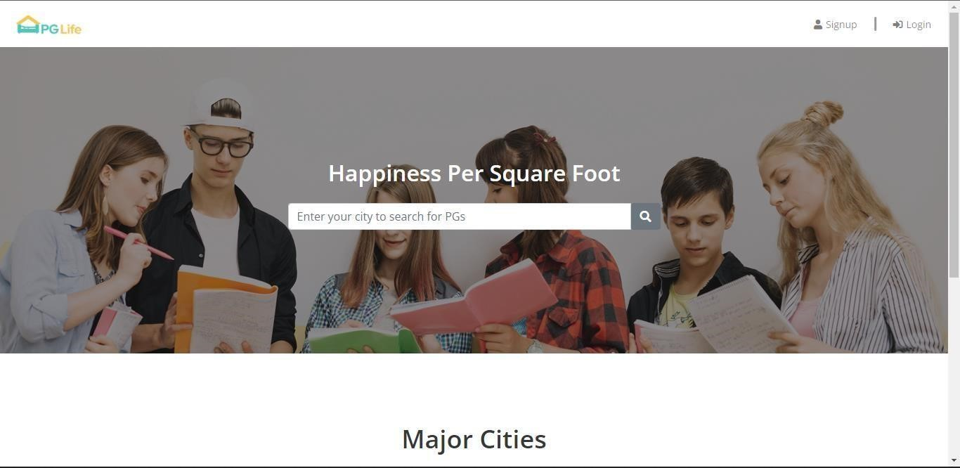

## Figure- 1: Index page

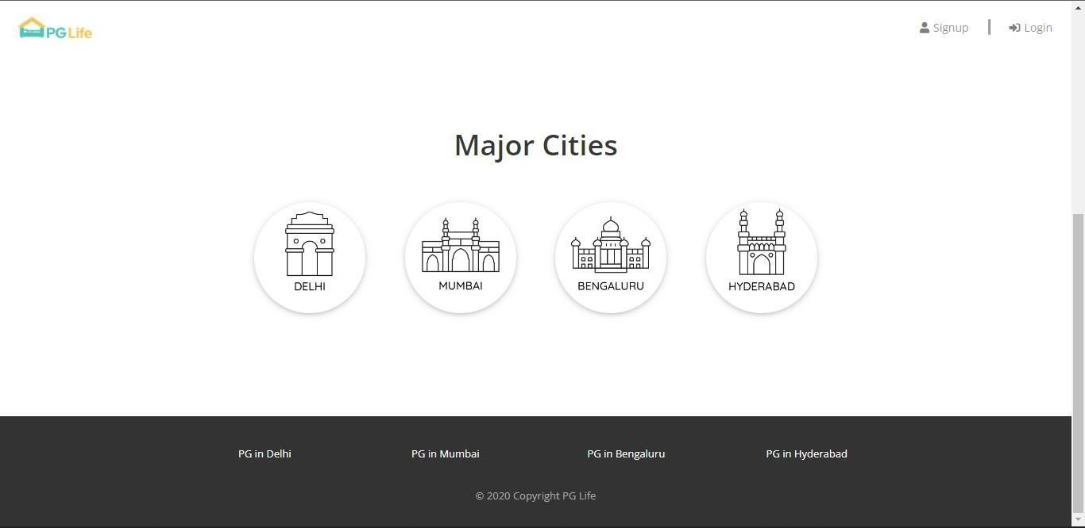

## Figure-2: CITIES

After this, JavaScript takes the role to add the functionalities of hover and On Click event handlers.

We also need to create database, for this, we are using PhpMyAdmin. We need 7 tables to store the varies of information which we will get from the user.

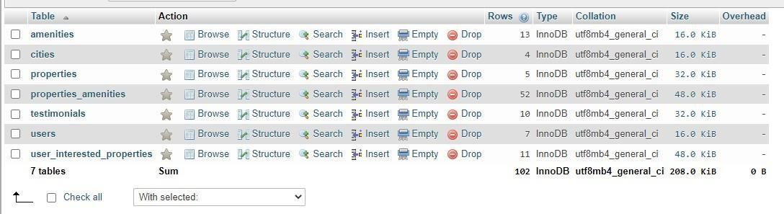

### **Figure-3: DATABASE TABLES**

* **Users –** in users table we will store the details of the user who had signed up in the PGLife website.
* **Cities –** in this tables will store the details of the cities where the properties are located.
* **Properties-** in this table we will store the detail information of the property which includes the details of property description, rent details and address, etc.,
* **User_interested_properties –** In this table, we will store the properties which were plotted as interested by the user along with the details of the user which marked it as interested.
* **Testimonials –** In this table, we will store the reviews on the property guven by the customer.
* **Amenities –** In this table, we will store all the amenities provided by all the properties like (WIFI, geyser, food, parking) facilities provided by the property owner.

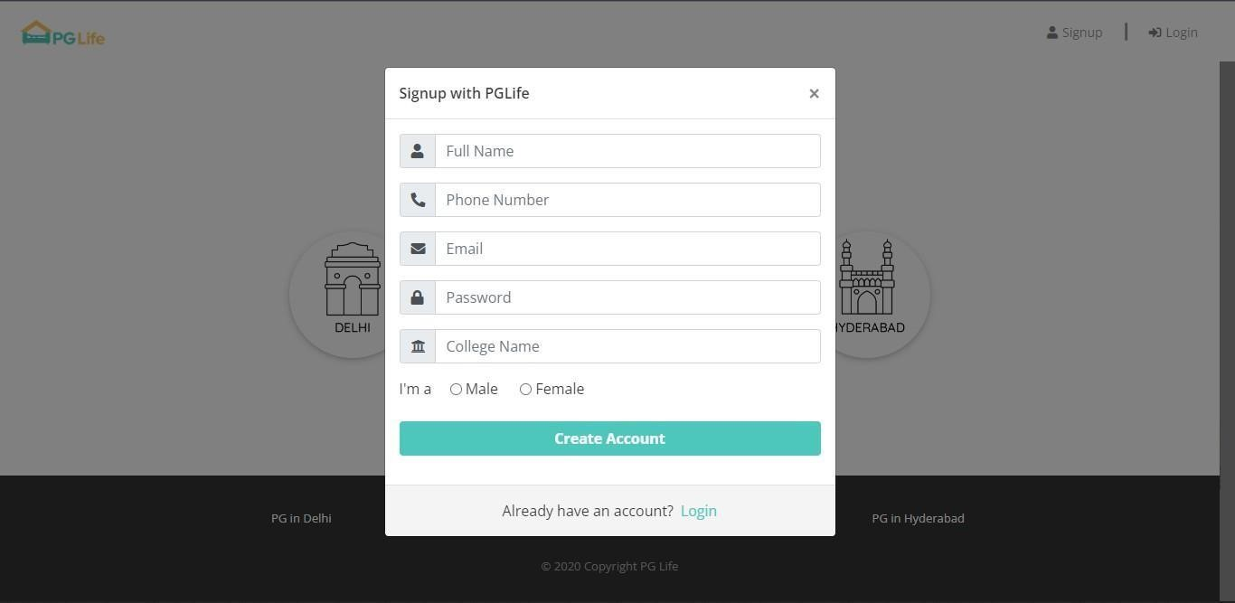

### **Figure-4:** SIGNUP FORM

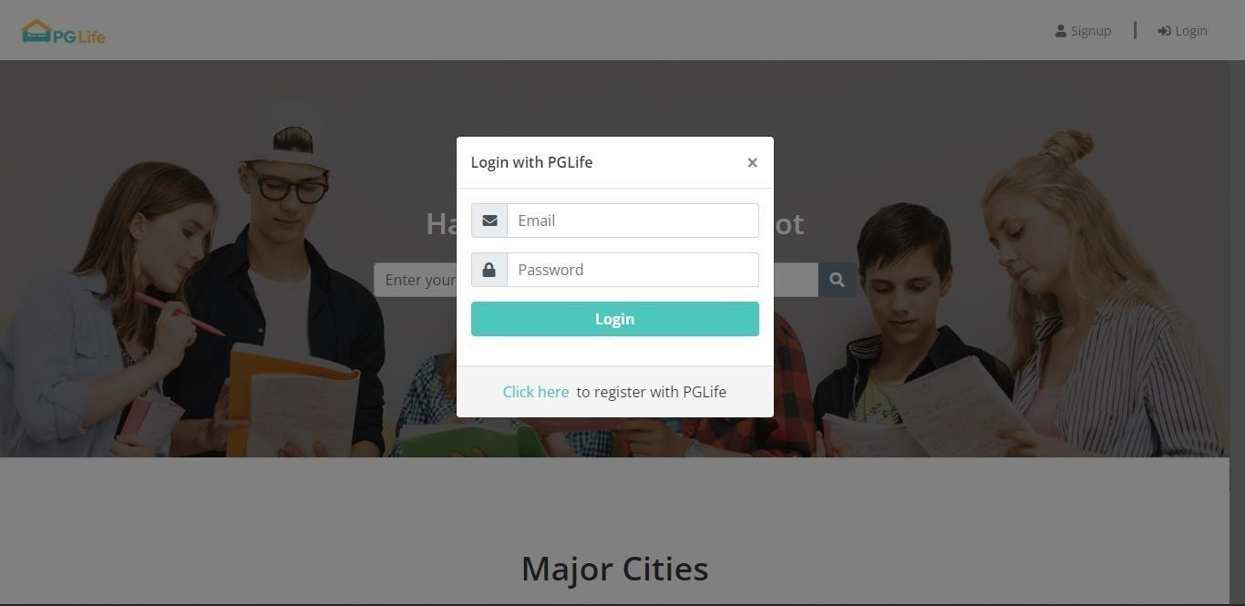

### **Figure-5:** LOGIN FORM

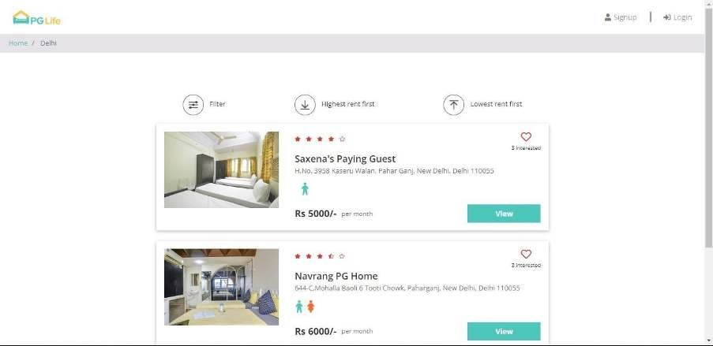

### **Figure-6:** PROPERTY LIST PAGE

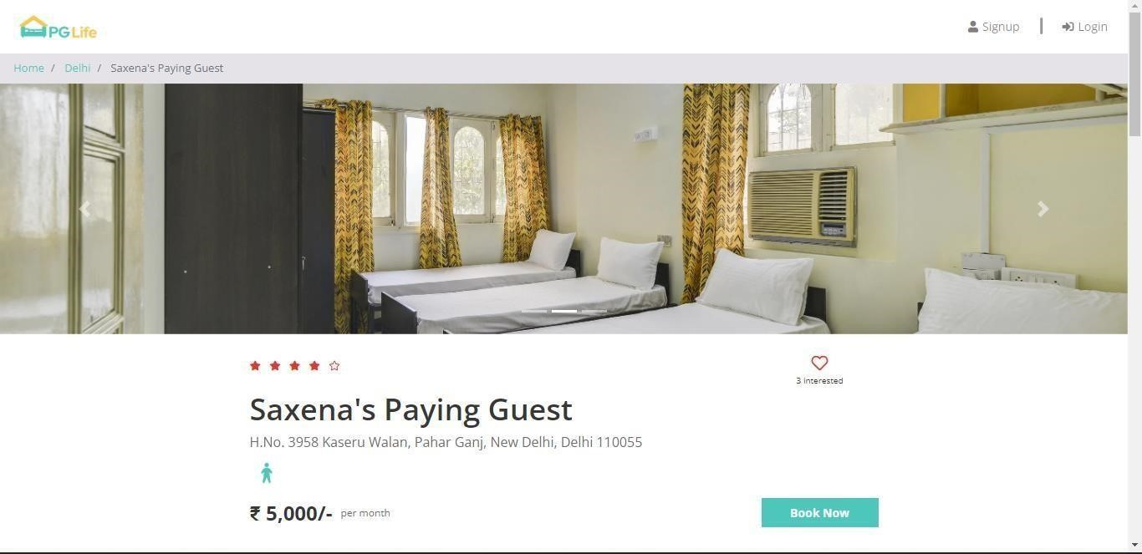

**Figure-7:** PROPETY DETAILS PAGE

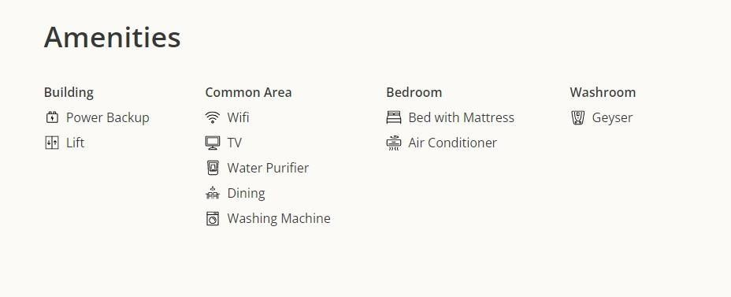

### **Figure-8:** AMENITIES SECTION IN PROPERTY DETAILS PAGE

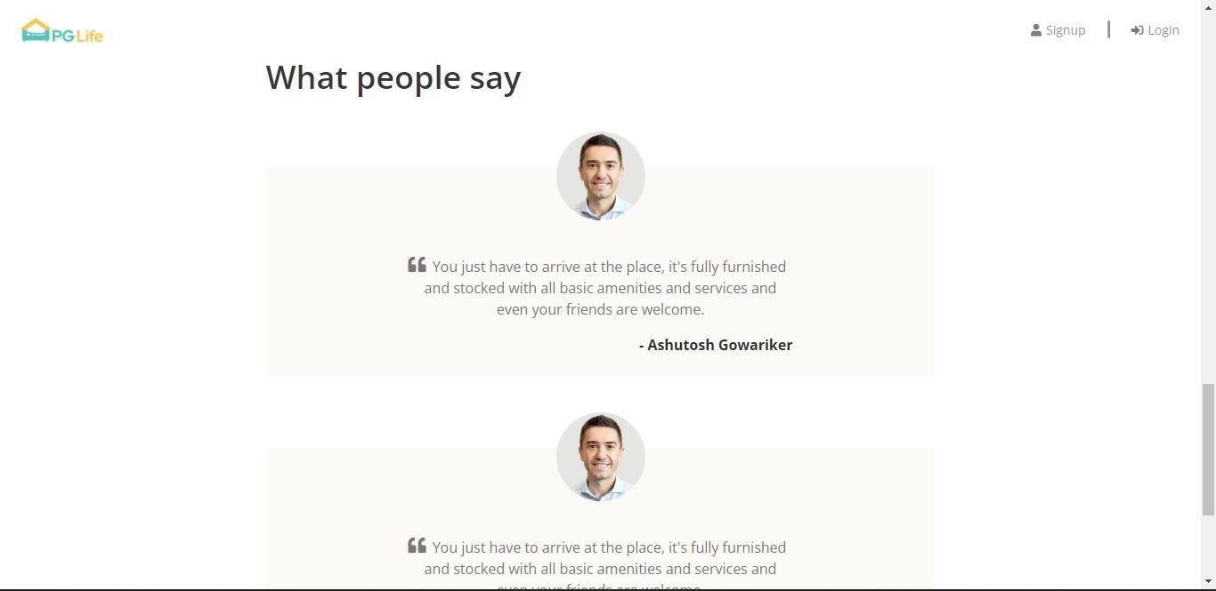

### **Figure-8:** TESTIMONIAL SECTION IN PROPERTY DETAILS PAGE

### **CHAPTER 4: METHODOLOGY ADOPTED**

Construct the web application with web development tools (HTML, CSS, Js, React, Bootstrap, DBMS, PHP), utilising all of the ideas covered in the course and concepts taught in the training, and create the database for the application with PhpMyAdmin.

The website is called PGLife. this project keeping in mind how challenging it is for the students to search for good accommodation when they join college/university. I guess we all might also have faced the challenge of finding good accommodation when you joined college.

So, this web application helps the students to get PGs in their desired cities with wonderful amenities and this web application have fully functional features which meets the requirements of today’s generation.

Each web-based project will be based on HTML and CSS. I have used HTML and CSS to give the basic structure to the web application.

I have also used Bootstrap front-end framework. This is used to make the website easier and faster. It includes pre-defined templates to make the web page more interactive.

PHP works as the back bone of this project as we know that retrieving data from the from the database is very much important. Front-end JavaScript also plays a major role to make a web page interactive.

**CHAPTER 5: RESULTS AND DISCUSSIONS**



## Figure- 1: Index page



**Figure-2: CITIES**



### **Figure-3: DATABSE TABLES**



### **Figure-4:** SIGNUP FORM



### **Figure-5:** LOGIN FORM

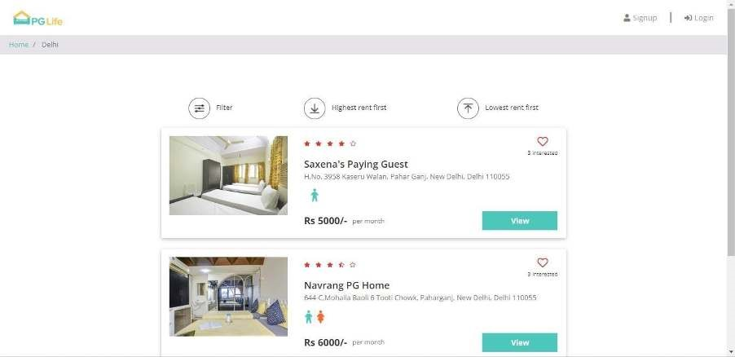

**Figure-6:** PROPERTY LIST PAGE



### **Figure-7:** PROPETY DETAILS PAGE



**Figure-8:** AMENITIES SECTION IN PROPERTY DETAILS PAGE



### **Figure-9:** TESTIMONIAL SECTION IN PROPERTY DETAILS PAGE

The very first thing is we need to design the web interface with the help of HTML, CSS, Bootstrap. We need to create an index page which works as index for all the pages, then we need to create login and signup page which slides on the index page when we click on the login/signup button,

we also need to create property list page which shows the properties of the selected city, followed with property list page, we also need to create property details page which gives the detailed structure of particular property and at last we need to design dashboard page. This page will be accessible only if the user logs in. We will check if the user logged in or not with the help of PHP sessions.

After this, JavaScript takes the role to add the functionalities of hover and On Click event handlers.

We also need to create database, for this, we are using PhpMyAdmin. We need 7 tables to store the varies of information which we will get from the user.

**CHAPTER 6 -- CONCLUSINS AND SCOPE FOR FUTURE STUDY**

This course has been helpful to me. Also, my confidence in web development developed because of the organised material, which included educational modules, assessments, hands-on practise, and assistance.

This web development training included instructive videos, tasks, projects, and a practise environment where I could put what I learned into reality. This helped to solidify my comprehension and application of the topics. and it was a pleasure to work on the project.

Web designing or web development is a short-term professional job-oriented course. There are huge opportunities available for the students who want to work in this field. Many private and public organizations hire web designer for their online work and website development. With the rapid advent of online industry, the demand of web development professionals is increasing, and this has created a huge job opportunity for the aspirants in the upcoming days.

Also, an experienced person in this field can also work as a freelancer; there are many online companies which provide online projects to the individuals.

## REFERENCES –

* <https://trainings.internshala.com/>
* <https://internshala.com/>
* <https://www.w3schools.com/>